Flask Installation:

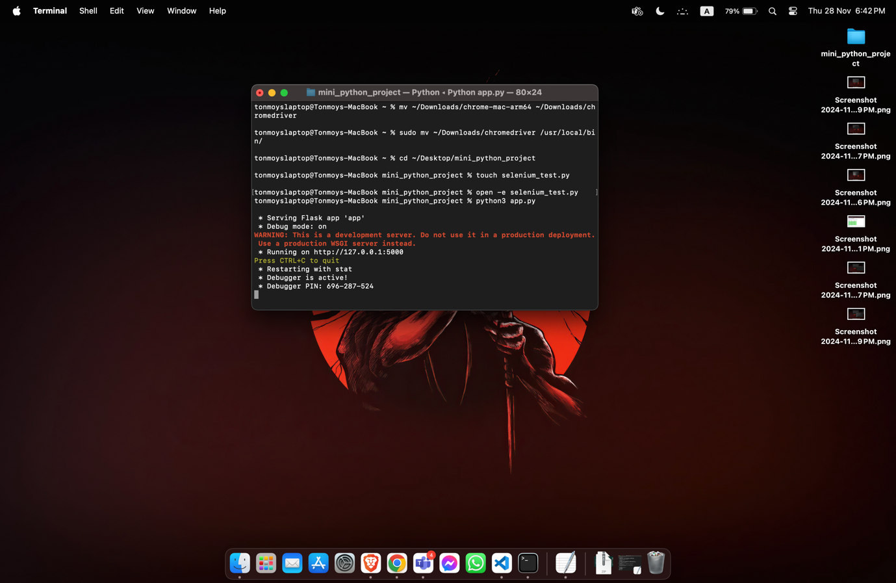

Selenium Installation:

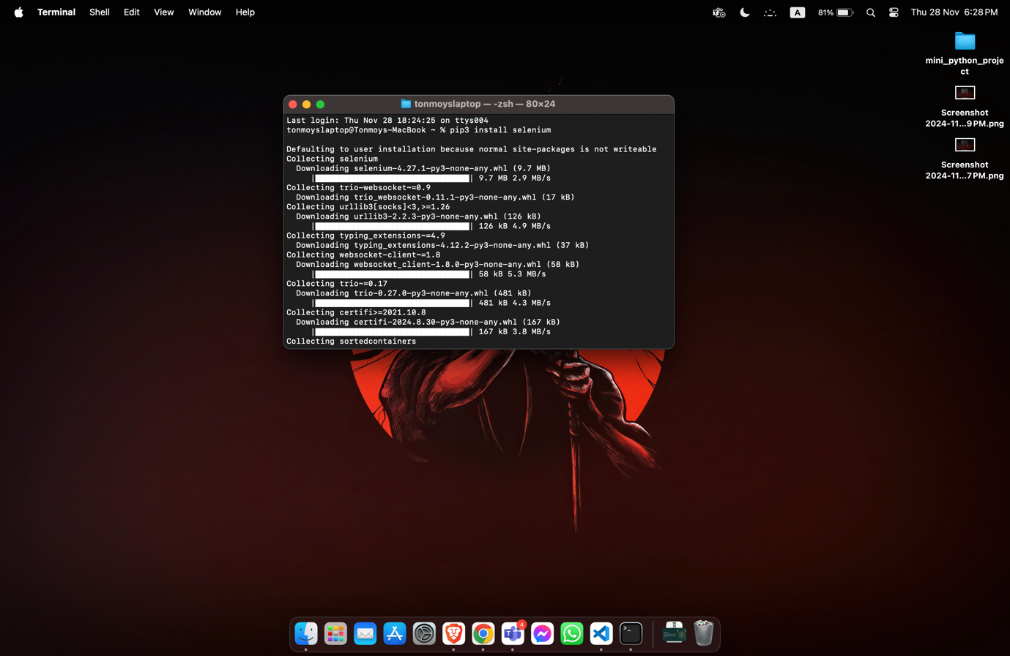

Chrome Driver Installation:   
  
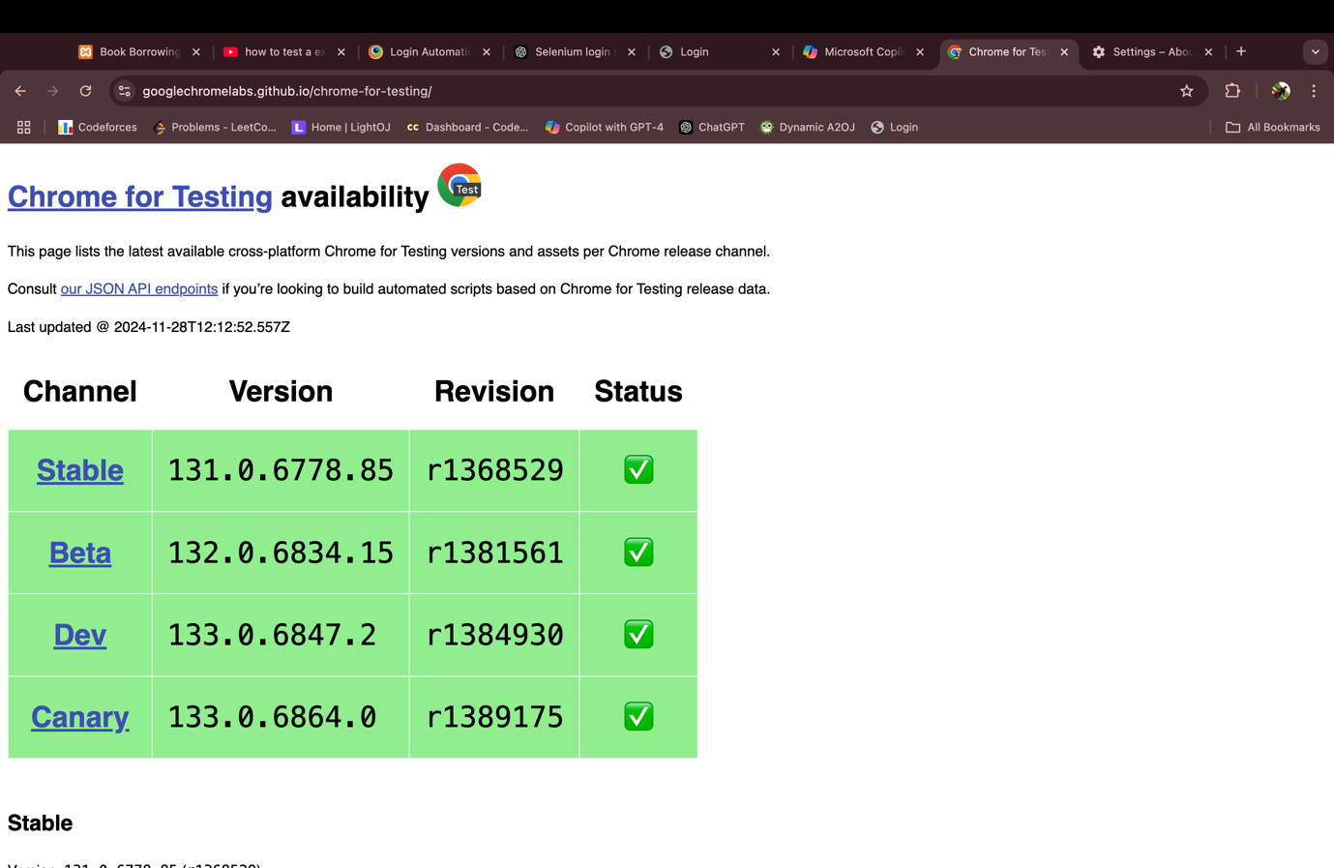

Running the python project:   
  


Running the selenium_test.py :

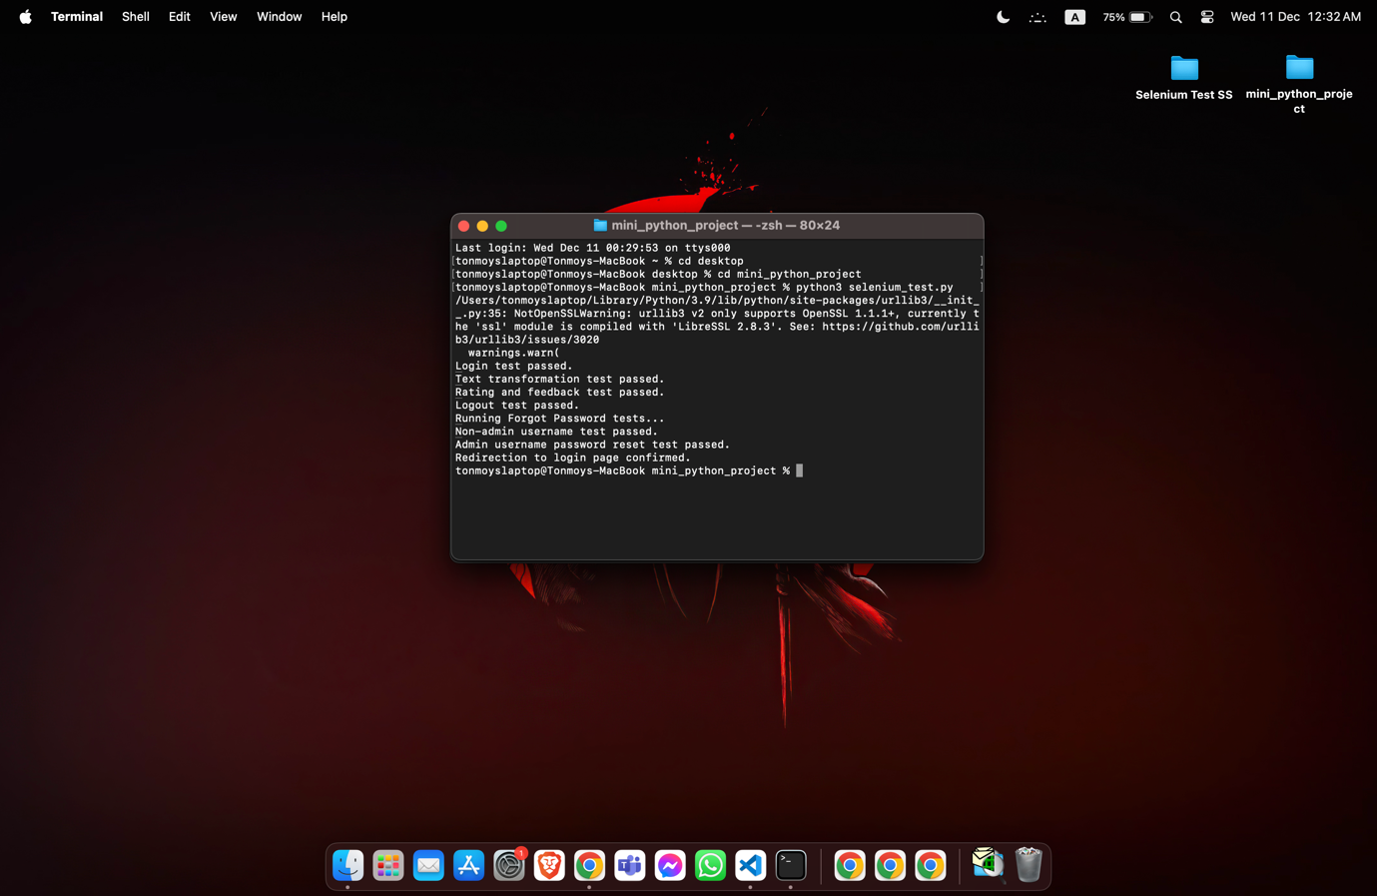

Selenium testing login and features:

Selenium testing rating and feedback feature:

Selenium testing logout and password reset:

Selenium tests output:

